**ASSIGNMENT 25.4**

1. **Write a hive query to find the top 20 destination people travel the most**

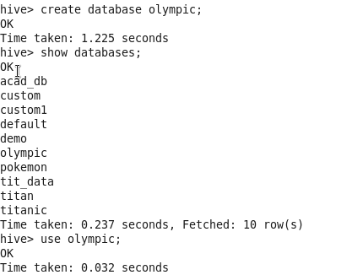

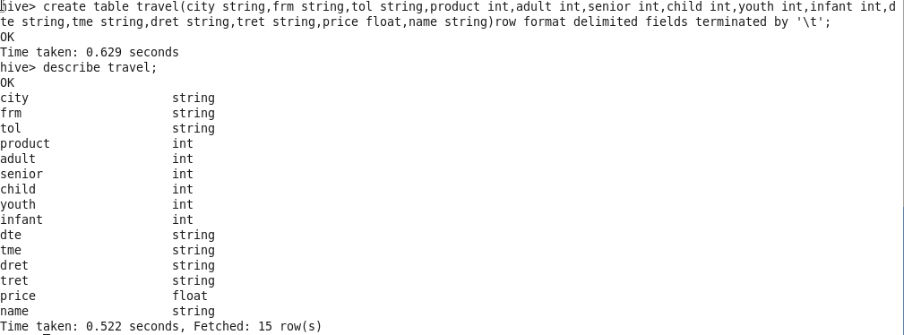

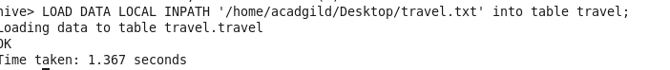

25.4query

Output

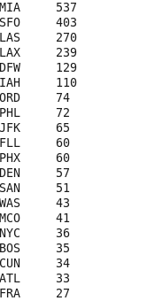

2. Write a hive query to find the top 20 locations from where people travel the most25.4bquery

OUTPUT

